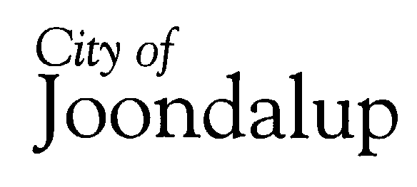

STRATEGY SESSION

The procedures for Strategy Sessions provide that, in specific instances when it is considered appropriate by elected members/Commissioners to be more fully informed on a matter, proponents may be invited to provide a presentation at a Strategy Session and in those instances headings of matters will be disclosed to the public.

Accordingly, it is advised that the following presentations will be made at the Strategy Session to be held on 24 May 2005:

- Ocean Reef Boat Harbour Development
- City of Joondalup’s Waste Management Strategy Review
- Public Participation Strategy
- Community Development Plan

